**Veracity: Car Insurance Fraud Detection Tool**

Paarth Makkar

13th January 2025

*Abstract*

Insurance fraud poses a significant threat to the stability of the insurance industry, contributing to billions in financial losses globally. The increasing sophistication of fraudulent claims necessitates a shift towards proactive, technology-driven detection solutions. This report introduces Veracity, an AI-powered fraud detection tool specifically designed for the auto insurance sector. By leveraging machine learning models, Veracity aims to identify fraudulent claims with high accuracy while maintaining a low false positive rate to minimize disruptions for legitimate claimants.

The report outlines the business, market, and regulatory needs driving the demand for advanced fraud detection tools. It presents the design and development process of the system, including data acquisition, model training, and the integration of explainable AI (XAI) to enhance transparency and user trust. Furthermore, it highlights the system’s real-time capabilities, scalability, and customizable features to meet the diverse needs of insurance agencies. Veracity not only addresses the growing threat of fraud but also aligns with industry regulations, data privacy laws, and ethical AI practices to ensure sustainable and responsible deployment.

Through a comprehensive analysis of market trends and competitor benchmarking, this report demonstrates the potential of Veracity to reduce fraudulent claims, safeguard policyholders, and improve the overall efficiency of claims processing. The tool's intuitive interface, interactive dashboards, and feedback mechanisms further emphasize its practicality for both businesses and users, reinforcing its value as a scalable, next-generation solution for fraud prevention in the auto insurance domain.

**1.0 Problem Statement:**

**1.1 Context: The Pervasive Problem of Insurance Fraud**

Insurance fraud occurs when an individual or entity intentionally deceives an insurance company to obtain a financial benefit. This can manifest in various ways, such as exaggerating losses, filing false claims, or staging accidents.

**1.1.1 Statistics:**

1. In the US, it's estimated that insurance fraud accounts for **10%** of insurance pay-outs.
2. Auto premium fraud accounts for **$35.1** Billion in insurance losses annually.
3. **60%** Indian insurers see a rapid rise in fraud – Deloitte.

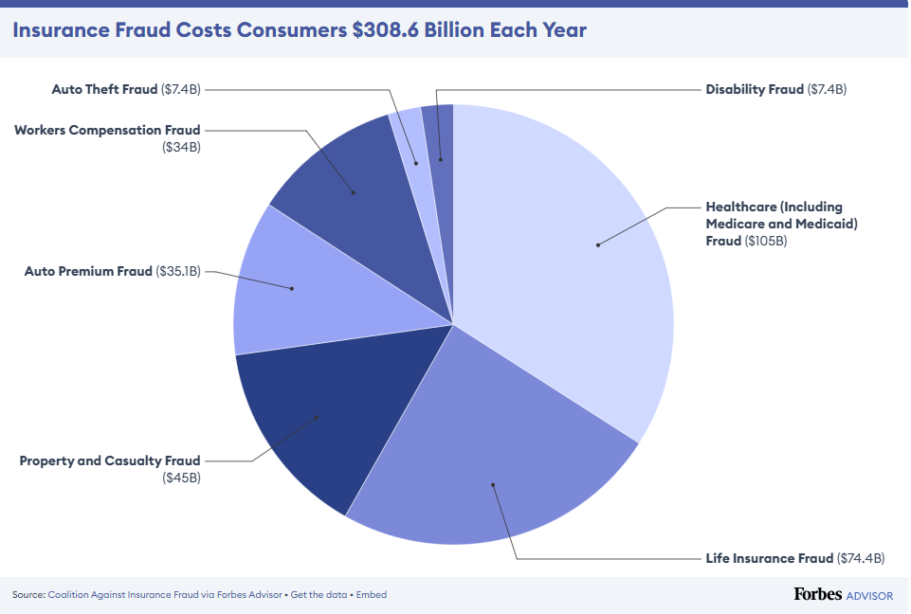

**1.2 Purpose: Protecting the Integrity of the Insurance Industry and Safeguarding Policyholders**

1. *Financial Impact on Insurance Companies:*

Fraudulent claims significantly impact insurance companies' profitability. High pay-outs due to fraud force insurers to increase premiums for all policyholders, leading to higher costs for consumers.

1. *Impact on Policyholders:*

Increased premiums due to fraud unfairly burden honest policyholders with the costs of fraudulent claims.

1. *Defamation:*

Widespread insurance fraud erodes public trust in the insurance industry, making it difficult for legitimate claimants to receive the benefits they are entitled to.

**1.3 Scope: Developing a Machine Learning-Powered Fraud Detection System for Auto Insurance**

1. *Focus on Auto Insurance:*

This project will specifically focus on developing a machine learning model to detect fraudulent claims within the context of auto insurance.

1. *Data-Driven Approach:*

Veracity will leverage historical claims data, including over **30+** initial covariates to fine tune the model for best output.

1. *Proactive Detection:*

The goal is to develop a system that can proactively identify suspicious claims before they are processed, allowing for faster investigation and reducing losses.

**1.4 Objectives:**

1. *Model Development and Training:*

Develop and train a machine learning model with high accuracy in detecting fraudulent auto insurance claims.

1. *False Positive Rate Minimising:*

Achieve a false positive rate below a specified threshold to minimize disruptions to legitimate claims processing.

1. *Model testing and validation:*

Demonstrate the model's effectiveness through rigorous testing and validation using real-world data.

1. *UI/UIX:*

Develop a user-friendly interface for users to easily interact with the model and access its predictions.

1. *Process Documentation:*

Document the entire development process including data collection, model selection, training, evaluation, and deployment for future reference.

**2.0 Needs assessment**

Need assessment builds an essential foundation for building a successful fraud detection tool. By thoroughly understanding our customers and their needs, we can create a product that is not only technically sound but also commercially viable and user-friendly.

**2.1 Market needs**

1. *Rising Fraudulent Activities*Fraudulent claims in the car insurance sector are increasing in sophistication, making traditional detection methods obsolete. The industry requires more advanced and automated tools to combat these fraudulent activities efficiently.
2. *Technological Advancements in Fraud Detection*There is a growing need for insurers to adopt AI-driven tools to keep up with the evolving tactics used by fraudsters. Machine learning and generative AI have proven to be effective in identifying complex fraud patterns and anomalies in claims.
3. *Regulatory Compliance*Insurance companies must comply with data privacy laws and anti-fraud regulations. Fraud detection tools need to incorporate mechanisms to ensure compliance with regulations such as IRDAI, ensuring sensitive user data is protected.
4. *Increasing Cost of Fraud*Fraudulent claims increase the overall cost of insurance policies, impacting both insurers and policyholders. The market is demanding cost-effective solutions that can reduce financial losses and maintain competitive pricing.

**2.2 Business Needs**

1. *Real-Time Fraud Detection*Insurance companies require tools that can detect fraud in real time to prevent pay-out of fraudulent claims. A delay in detection can result in significant financial losses for businesses.
2. *Risk Scoring and Predictive Analytics*There is a business need for fraud detection tools to include risk-scoring models that predict the likelihood of a claim being fraudulent. This helps businesses prioritize which claims to investigate further, improving operational efficiency.
3. *Scalability*Insurance businesses need solutions that are scalable and can handle large volumes of claims without a significant increase in operational costs. AI-driven tools that learn and improve over time can meet this requirement.
4. *Fraud Prevention to Protect Profit Margins*Implementing a robust fraud detection system can help protect profit margins by reducing pay-outs on fraudulent claims.
5. *Integration with Existing Systems*Businesses need fraud detection tools that can seamlessly integrate with their existing claims processing systems to avoid disrupting operations. This ensures smooth adoption of new technology.

**2.3 Customer Needs**

1. *Fast and Fair Claims Processing*Customers expect their legitimate claims to be processed quickly and fairly. Fraudulent claims slow down the process, leading to dissatisfaction among honest policyholders. Veracity can help speed up the process for genuine claims by reducing the time spent on investigating fraudulent ones.
2. *Protection Against Rising Premiums*Fraudulent claims drive up premiums for all policyholders. Customers want insurance companies to take proactive measures to reduce fraud and maintain affordable premiums.
3. *Transparency in Fraud Detection*Customers are more likely to trust insurers who provide transparency in how claims are evaluated for potential fraud. An explainable AI model that clearly outlines why a claim is flagged as suspicious can build customer trust.
4. *Data Privacy and Security*Customers are increasingly concerned about how their data is handled. Veracity must ensure robust data privacy measures to safeguard customer information.

**3.0 Target Specifications:**

**3.1 Insurance Agencies:** Established insurance companies looking for advanced fraud detection solutions to improve claim processing efficiency and reduce financial losses.

* + 1. **Reasons for targeting:**

1. *High-Value Market:*

Insurance agencies face significant losses due to fraud and are actively seeking innovative solutions to mitigate these risks.

1. *Revenue Generation:*

Provides a sustainable revenue stream for the business.

1. *Tailored Solutions:*

Offers customized features and integrations based on specific agency needs.

1. *Pilot Programs:*

Conduct pilot programs with a select group of insurance agencies to gather feedback on the paid solution and its effectiveness.

* + 1. **Metrics for continuous improvement:**

1. Number of paying subscribers.
2. Customer satisfaction (measured through surveys and feedback).
3. Return on investment (ROI) for insurance agencies using the paid solution (e.g., reduction in fraudulent claims, improved claim processing speed).

**3.2 Explorers:** These are individuals, students, researchers, or anyone interested in learning about and experimenting with machine learning-based fraud detection in the insurance domain.

* + 1. **Reasons for targeting:**

1. *Educational Value:*

Provides a platform to understand how AI can be applied to detect fraud claims.

1. *Market Research:*

Gather user insights that can inform the development of the paid enterprise solution.

1. *Surveys:*

Conduct surveys to gather feedback on the website's design, usability, and features.

1. *User Testing:*

Conduct usability testing with a small group of explorers to identify areas for improvement.

* + 1. **Metrics for continuous improvement:**

1. Number of unique visitors to the website.
2. User engagement – time spent on the website; number of claims submitted for analysis.
3. User feedback and reviews.

**4.0 Features:**

1. *Explainable AI Capabilities:*

The tool should be able to explain the factors that contributed to a specific fraud prediction. This builds trust with users and allows them to understand and interpret the model's decisions.

1. *Third – Party Data Sources:*

Integrate with third-party data sources such as credit bureaus, public records, client’s database, social media (with appropriate privacy considerations) to enrich the risk assessment and identify potential flags.

1. *Real – Time Data Feed:*

Incorporate real time data feeds from various sources to enable real-time fraud detection for Insurer’s data and identify potential red flags.

1. *Automated Workflow Integration:*

Seamlessly integrate with existing insurance workflows, such as claims management systems and policy administration systems, to streamline the fraud detection process.

1. *Automated Decision Making:*

Automate routine tasks such as claim triage and initial fraud assessments, freeing up adjusters to focus on more complex cases.

1. *ML model updates:*

Continuously train and update the machine learning models with new data and insights to improve accuracy and adapt to evolving fraud patterns.

1. *Feedback Mechanism:*

Implement feedback mechanisms to allow users to provide feedback on model predictions, enabling continuous improvement of the system.

1. *Interactive dashboards:*

Provide interactive dashboards and reports that visualise KPIs, such as fraud detection rates, false positive rates, and cost savings.

1. *Customizable alerts and notifications:*

Allow users to customize alerts and notifications based on their specific needs and risk tolerance.

1. *User friendly Interface:*

Provide user friendly environment to enhance engagement and focus levels for beginners or professionals alike.

**5.0 Benchmarking:**

* 1. **Summary of Benchmarking results:**

1. The table reveals that while several vendors offer robust fraud detection solutions, there are areas where opportunities exist for differentiation. LexisNexis Risk Solutions, SAS, and FICO all demonstrate strong capabilities in leveraging third-party data sources and offer some level of automated decision-making. However, Explainable AI (XAI) capabilities appear to be lacking across the board, with only a few vendors offering limited XAI features. Similarly, while most vendors provide some level of integration with existing systems, automated workflow integration and real-time data feeds are not consistently present.
2. Furthermore, the table highlights a gap in the market for solutions with advanced anomaly detection capabilities, such as behavioural analytics and network analysis. Finally, while most vendors emphasize data security and privacy, the level of transparency in fraud detection varies significantly, with limited options for providing users with clear and understandable explanations of model predictions.
3. These findings suggest that there is a market need for a comprehensive fraud detection solution that combines advanced machine learning techniques with robust XAI capabilities, seamless integration with existing systems, and a strong focus on user experience and transparency.

|  |  |  |  |  |  |
| --- | --- | --- | --- | --- | --- |
| **Features** | **LexisNexis Risk Solutions** | **SAS** | **Quantexa** | **FICO** | **BPC** |
| *Explainable AI capabilities* | ✔️ | ❌ | ❌ | ❌ | ❌ |
| *Third-Party Data Sources* | ✔️ | ✔️ | ❌ | ✔️ | ✔️ |
| *Real – Time data feed* | ✔️ | ✔️ | ✔️ | ✔️ | ✔️ |
| *Automated Workflow Integration* | ✔️ | ✔️ | ✔️ | ❌ | ✔️ |
| *Automated Decision Making* | ✔️ | ✔️ | ❌ | ✔️ | ❌ |
| *ML model updates* | ✔️ | ✔️ | ✔️ | ✔️ | ✔️ |
| *Feedback mechanisms* | ✔️ | ✔️ | ❌ | ✔️ | ❌ |
| *Interactive dashboards* | ❌ | ❌ | ✔️ | ✔️ | ✔️ |
| *Customizable alerts and notifications* | ❌ | ✔️ | ❌ | ❌ | ❌ |
| *User friendly Interface* | ❌ | ❌ | ✔️ | ✔️ | ✔️ |

**6.0 Applicable Patents**

Some applicable patents include:

1. *Machine Learning-Enabled System for Real-Time Performance Monitoring and Risk Assessment in Business Operations*

* This innovative system integrates advanced machine learning models, including anomaly detection, predictive analytics, and risk scoring, with real-time data aggregation from diverse sources such as operational systems, financial tools, and external datasets.

1. *Neural Network-based Fraud Detection in Financial Transactions*

* This system starts with the processing of real time transaction data to find the fraud anomaly indicatives. By using the deep learning techniques such as CNNs and RNNs, the system gets the high accuracy of identifying fraud patterns. It also connects with the financial platforms which are already available to provide the user-friendly interface and monitor the suspicious activities and generating alerts.

**7.0 Applicable Regulations**

Some applicable regulations are as follows:

**7.1 Governmental Regulations**

1. *Personal Data Protection Bill, 2019*

* The Personal Data Protection Bill, 2019 (PDP Bill) is currently under consideration and aims to establish a comprehensive framework for protecting personal data. The bill introduces principles and obligations for entities processing personal data, including consent, purpose limitation, data localization, and accountability. Additionally, it proposes the creation of a Data Protection Authority to oversee and enforce the provisions of the bill. The PDP Bill includes provisions addressing profiling and automated decision-making. It mandates explicit consent from individuals when processing personal data using AI algorithms that significantly impact their rights and interests. We should focus on obtaining valid consent, ensuring data security and privacy, establishing data breach notification procedures.

1. *Information Technology Act, 2000*

* The Information Technology Act, 2000 (IT Act) serves as the fundamental legislation governing electronic transactions and digital governance. Although it does not explicitly mention AI, specific provisions within the Act are applicable to AI-related activities. Section 43A of the IT Act enables compensation in case of a breach of data privacy resulting from negligent handling of sensitive personal information. This provision is particularly relevant in the context of AI systems that process user data. Another provision is Section 73A of this act. We should focus on implementing robust security measures, protecting user data from cyber threats, complying with data breach notification requirements.

1. *IRDAI*

* The Insurance Regulatory and Development Authority of India foresees each insurance institution and have specific regulations governing insurance practices in India. Veracity should comply with IRDAI and stay up-to-date about latest regulations. We should focus on understanding and complying with IRDAI guidelines on data usage, risk management, and consumer protection within the insurance sector.

1. *Competition Act, 2002*

* Veracity should not create any anti-competitive practices or hinder fair competition within the insurance market. Avoiding any actions that could lead to market dominance or unfair advantage for certain insurers should be our utmost priority.

1. *Indian Copyright Act, 1957*

* The Indian Copyright Act, 1957 safeguards original literary, artistic, musical, and dramatic works, granting exclusive rights to creators and prohibiting unauthorized use or reproduction. The rise of AI-generated content has prompted discussions regarding copyright ownership and infringement liability.

1. *General Data Protection Regulations (GDPR)*

* GDPR sets a high standard for data protection and privacy. When we expand our reach to individuals and organisations located in European Union, we must comply with GDPR. We should focus on obtaining valid consent and ensure data security.
  1. **Environmental Regulations**

1. *Energy Consumption:*

* Training and running AI models can consume sizable amount of energy, thus contributing to greenhouse gas emissions.
* Our focus should be on using energy – efficient GPUs with high compute – to – power ratios and server infrastructure with high power usage effectiveness.
* Alternative approach can be utilizing cloud providers that rely on renewable energy sources for their data centres.

1. E – waste management:

* Disposal of electronic equipment, including servers, storage devices and other hardware used to run the model can contribute to e – waste pollution.
* Partnering with certified e – waste recyclers for proper disposal of electronic equipment can contribute positively to environment.

Regularly conducting an environmental impact assessment of Veracity can help identify and mitigate potential environmental risks. The principle of 3 R’s should be a great starting point before any endeavour.

**8.0 Applicable Constraints**

Some key constraints to consider are:

**8.1 Budget Constraints:**

1. *Development Costs:*

* R&D, data acquisition, model training, and infrastructure costs can be significant.

1. *Maintenance Costs:*

* Ongoing costs for data updates, model retraining, system maintenance, and customer support is something to be taken care of.

1. *Talent Acquisition:*

* Attracting and retaining top-tier AI talent (data scientists, engineers, etc.) can be expensive.

1. *Marketing and Sales:*

* Costs associated with marketing the product, building sales channels, and acquiring customers are some indirect costs associated.
  1. **Time Constraints:**

1. *Development Time:*

* Bringing a sophisticated AI-powered product to market requires significant time for research, development, testing, and refinement.

1. *Time-to-Market:*

* The need to quickly launch the product to gain market share and capitalize on opportunities can create time pressures.

1. *Regulatory Compliance:*

* Navigating and complying with evolving regulations (e.g., data privacy, cybersecurity) can be time-consuming.

**8.3 Data Constraints:**

1. *Data Availability:*

* Accessing high-quality, labeled data for training and validating the fraud detection model is crucial. Obtaining sufficient and diverse data can be challenging.

1. *Data Quality:*

* Ensuring data accuracy, completeness, and consistency is critical for model performance. Data cleaning and preprocessing can be time-consuming and resource-intensive.

1. *Data Privacy and Security:*

* Maintaining the confidentiality and security of sensitive data is paramount. Implementing robust data security measures and complying with data privacy regulations adds complexity and cost.

**8.4 Expertise Constraints:**

1. *AI Talent:*

* Finding and retaining skilled AI professionals with expertise in machine learning, deep learning, natural language processing, and data engineering can be challenging.

1. *Domain Expertise:*

* Acquiring and maintaining in-house expertise in the insurance industry and fraud detection is essential for effective product development and customer support.

**8.5 Technological Constraints:**

1. *Computational Resources:*

* Training and deploying sophisticated AI models require significant computational resources, such as high-performance computing (HPC) infrastructure and powerful GPUs.

1. *Scalability and Performance:*

* Ensuring the tool can handle large volumes of data and process claims in real-time while maintaining high performance and accuracy is a critical technological challenge.

**8.6 Competitive Constraints:**

1. *Market Competition:*

* The market for fraud detection solutions is competitive, with established players offering robust solutions. Differentiating our product and gaining market share will require significant effort and innovation.

1. *Competitive Pricing:*

* The need to offer competitive pricing while maintaining profitability will require careful consideration of costs and revenue streams.

**9.0 Business Model**

**9.1 Tier 1: Explorers (Free Tier with Monetization)**

**9.1.1 Freemium Model:**

1. *Basic Functionality:*

* Offer core functionality (basic fraud detection, limited data input) for free on a website.

1. *Monetization:*

* Ads: Display non-intrusive ads on the website.
* Premium Features (Paywall): Introduce premium features behind a paywall:
  + *Unlimited Usage:* Remove limits on policy evaluations per day.
  + *Advanced Features:* Offer access to more advanced features like data visualization, detailed reports, and integration with other tools.
  + *Faster Processing:* Reduce or eliminate delays between policy inputs.
* Tiered Subscriptions: Offer different subscription levels with varying feature sets and pricing.

**9.1.2 Educational Content:**

1. *Free Courses/Tutorials:*

* Offer free educational content (e.g., blog posts, webinars, white papers) on fraud detection, machine learning, and insurance.

1. *Monetization:*

* Sponsored Content: Partner with relevant companies to offer sponsored content and educational resources.
* Affiliate Marketing: Promote related products or services (e.g., data analysis tools, cybersecurity software) through affiliate marketing programs.

**9.2 Tier 2: Insurance Agencies (Paid Subscriptions)**

* + 1. **Subscription Model:**
  1. *Tiered Pricing:*
* Offer different subscription tiers based on the number of users, data volume, and features accessed all on a dedicated app.
  1. *Usage-Based Pricing:*
* Charge based on the number of claims processed or the volume of data analyzed.
  1. *Value-Based Pricing:*
* Base pricing on the estimated value delivered to the insurance agency (e.g., reduction in fraud losses, improved efficiency).

**9.2.2 Value-Added Services:**

1. *Consulting Services:*

* Offer consulting services to help insurance agencies implement and optimize the fraud detection solution.

1. *Custom Integrations:*

* Provide custom integrations with specific agency systems and workflows.

1. *Training and Support:*

* Offer training programs and ongoing support services to ensure successful adoption and utilization of the tool.

**9.3 Additional Monetization Strategies:**

1. *Data Licensing:* If your model is trained on a large and valuable dataset, consider licensing anonymized and aggregated data insights to other companies or research institutions.
2. *Partnerships:* Partner with other companies in the insurance ecosystem, such as claims adjusters, investigators, or legal firms, to offer integrated solutions.
3. *White-Labeling:* Offer your fraud detection technology to other companies to be integrated into their own products or services under their brand.

**10.0 Concept Generation**

The genesis of this fraud detection tool stems from the observation of AI's transformative impact across diverse sectors, extending beyond traditional applications. In healthcare, AI is revolutionizing diagnostics, drug discovery, and personalized medicine, drawing inspiration for its potential within the insurance domain. The rise of synthetic biology further emphasizes the rapid pace of technological advancement and its potential to disrupt established industries.

Given the strong interlinkage between healthcare and insurance, particularly in the context of health insurance, where sophisticated fraud detection tools are already in place, it became evident that AI could also play a crucial role in other areas of the insurance industry. Initial research indicated that the automobile insurance sector, with its complex claims processes and vulnerability to various forms of fraud, presented a promising area for AI-driven solutions.

However, the initial stages of research presented several challenges. A clear vision for the tool's functionality, features, and user interface remained elusive. As a relatively young student, my prior experience primarily revolved around data science fundamentals, encompassing data set cleaning, exploration, model training, and testing. My understanding of business model development and the intricacies of building and maintaining a web application was limited.

Despite these initial hurdles, the project offered a valuable opportunity for personal and professional growth. Embarking on this journey has necessitated continuous learning and adaptation, fostering a deeper understanding of business principles, web development, and the complexities of translating a technical solution into a viable product.

**11.0 Concept Development**

The website interface is designed with a minimalist aesthetic, emphasizing clarity and ease of use. A soothing greenish-blue color scheme, accented with subtle cyan highlights, creates a visually appealing and professional atmosphere. The website layout is clean and uncluttered, with key elements strategically placed.

**11.1 Key Interface Elements:**

1. *Navigation:* A prominent logo and branding elements are situated in the top left corner, while a user login feature is conveniently located in the top right corner. A central dropdown menu provides easy navigation to key sections of the website, including the core fraud detection tool, educational content, and other relevant information.
2. *Tool Presentation:* The core fraud detection tool is presented within a visually engaging "card format." Each input field occupies a distinct card with softly glowing edges, creating a dynamic and interactive user experience. The "card swipe" animation enhances the user experience by providing a smooth and intuitive transition between input fields. A "back" button allows users to easily revise or update previous entries.
3. *Visual Appeal*: The website incorporates visual elements, such as data visualizations, charts, and infographics, to enhance user engagement and provide a more intuitive understanding of the tool's capabilities and the results it generates.

**11.2 User Experience (UX) Focus:**

1. *Intuitive Navigation:* The website is designed to be highly intuitive and easy to navigate, ensuring a seamless user experience for both technical and non-technical users.
2. *Clear and Concise Information:* All information presented on the website is clear, concise, and easy to understand, ensuring that users can quickly grasp the key features and benefits of the tool.
3. *Interactive Elements:* The use of interactive elements, such as the card-based interface and animations, enhances user engagement and makes the experience more enjoyable.
4. *User Feedback:* The website incorporates mechanisms for gathering user feedback, such as surveys and feedback forms, to continually improve the user experience.

Overall, the website's design aims to create a user-friendly and engaging experience that effectively communicates the value proposition of the fraud detection tool while maintaining a professional and sophisticated aesthetic.

**12.0 Final Product Prototype**

**12.1 System Level Description**

**12.1.1 Frontend (Client)**

This tier comprises the user interface (website and app) responsible for capturing user input, displaying results, and facilitating user interaction.

**12.1.2 Backend (Server)**

This tier houses the core functionalities, including the machine learning model, data processing pipelines, and backend services.

**12.2 Subsystem Level Description**

**12.2.1 Frontend**

1. *Website*

* *Homepage:* Displays key information, features, testimonials, and a call to action.
* *Tool Page:* Handles user input, processes requests, and displays results.
* *Educational Content:* Provides access to articles, tutorials, and community forums.
* *User Authentication:* Handles user login, registration, and session management.

1. *App (Tier 2 – Insurance Agencies)*

* *Dashboard:* Displays real-time alerts, KPIs, and interactive visualization.
* *Claim Processing Integration:* Enables seamless integration with existing agency systems.
* *Administration Panel:* Allows administrators to manage user roles, access settings, and system configurations.

**12.2.2 Backend (Server)**

1. *Machine Learning Model*

* *Model Training and Deployment:* Responsible for training, testing, and deploying the fraud detection model.
* *Model Prediction:* Receives input data from the frontend, processes it, and generates predictions.
* *Model Monitoring and Maintenance:* Continuously monitors model performance, identifies areas for improvement, and retrains the model as needed.

1. *Data Processing Pipelines:*

* *Data Ingestion:* Receives and processes data from various sources (e.g., user input, external APIs).
* *Data Cleaning and Transformation:* Cleanses and transforms data to prepare it for model input.
* *Data Storage and Management:* Stores and manages data securely and efficiently.

1. *Server Management:*

* *Infrastructure Management:* Manages and maintains the server infrastructure (e.g., cloud servers, databases).
* *System Monitoring:* Monitors system performance, resource utilization, and system health.
* *Security Management:* Implements security measures to protect the system from cyber threats.

**12.3 Component Level Description**

**12.3.1 Frontend (Client):**

1. *UI Components:* HTML, CSS, JavaScript libraries (e.g., React, Angular) for building interactive user interfaces.
2. *API Integration:* APIs to communicate with the backend server and retrieve data.
3. *User Authentication:* Authentication and authorization mechanisms (e.g., OAuth, JWT).

**12.3.2 Backend (Server):**

1. *Machine Learning Framework:* Libraries and tools for model development and deployment (e.g., TensorFlow, PyTorch, scikit-learn).
2. *Data Processing Libraries:* Libraries for data cleaning, transformation, and feature engineering (e.g., Pandas, NumPy).
3. *Database:* Relational database (e.g., PostgreSQL, MySQL) or NoSQL database (e.g., MongoDB) for storing and managing data.
4. *Serverless Computing:* Utilizing serverless functions (e.g., AWS Lambda, Google Cloud Functions) for scalable and cost-effective execution.
5. *API Gateway:* A gateway for managing API requests and responses.

**12.4 Design Refinement Process:**

1. *Iterative Development:* The design process will be iterative, with continuous feedback and refinement based on user testing and market research.
2. *Agile Methodology:* Utilizing agile development methodologies (e.g., Scrum, Kanban) to facilitate flexibility and adaptability.
3. *User-Centered Design:* Prioritizing user needs and preferences throughout the design process.
4. *Prototyping and Testing:* Creating and testing prototypes early in the development process to gather user feedback and identify areas for improvement.
5. *Continuous Improvement:* Continuously monitoring system performance, gathering user feedback, and iteratively refining the design based on insights and learnings.

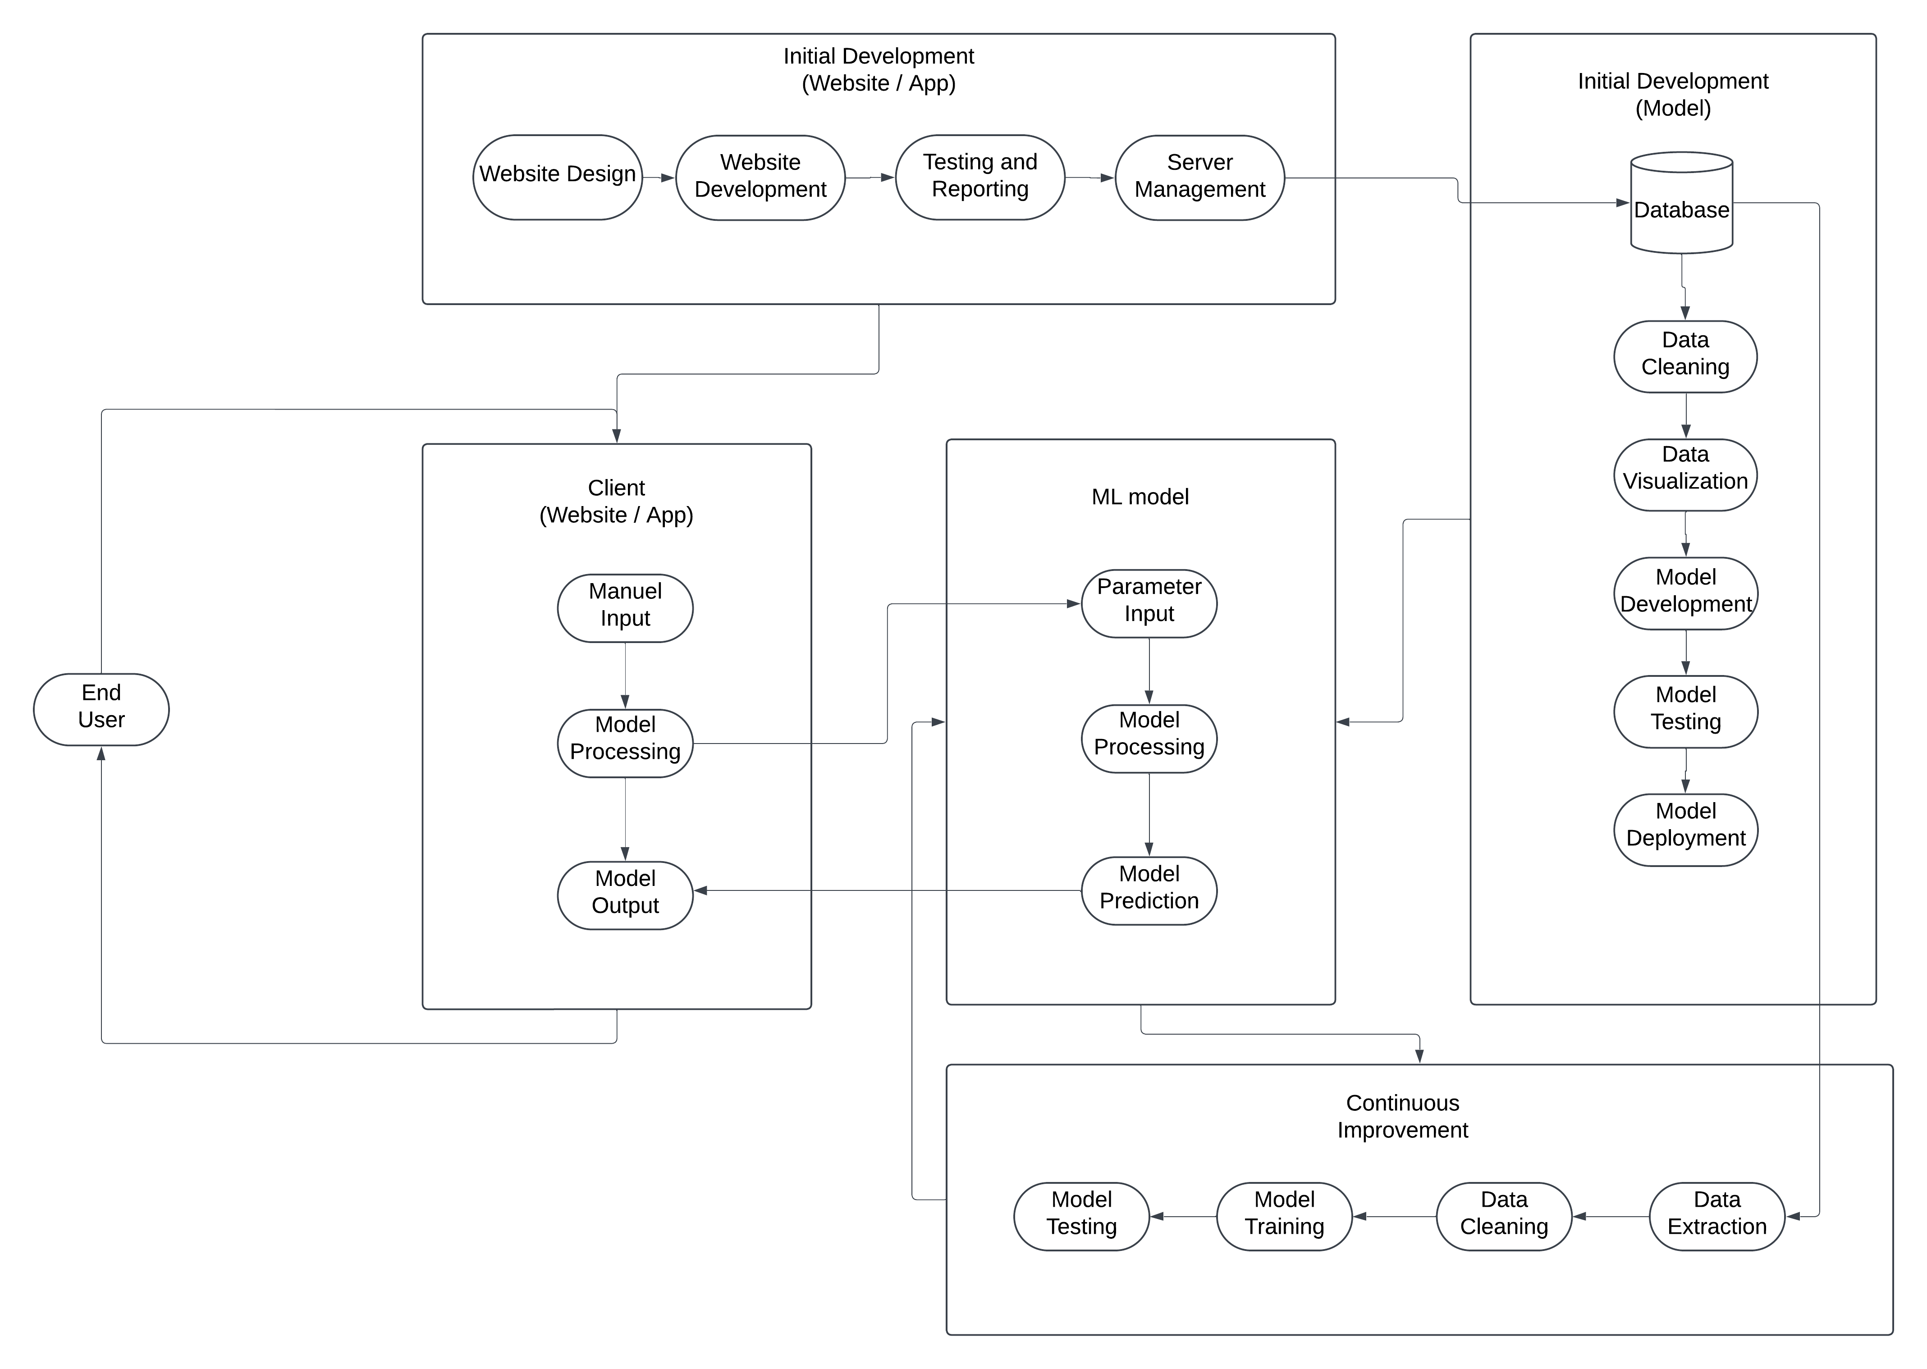

This detailed design description provides a comprehensive overview of the system architecture and the design refinement process. By following this iterative and user-centered approach, we can ensure that the final product meets the needs of both Explorers and Insurance Agencies while maintaining high performance, scalability, and security.

**13.0 Product Details**

**13.1 How Does the Tool Work?**

1. *Data Input*: Users input relevant claim information into the tool via the web interface or API.
2. *Data Processing:* The input data is preprocessed and cleaned to ensure data quality and consistency.
3. *Model Prediction*: The preprocessed data is fed into the machine learning model, which analyzes the information and predicts the likelihood of fraud.
4. *Output and Visualization:* The model's prediction is presented to the user in a clear and concise format, often accompanied by visualizations and explanations of the factors contributing to the prediction.
5. *User Interaction:* Users can interact with the tool by adjusting input parameters, exploring different scenarios, and accessing additional information and resources.

**13.2 Data Sources:**

1. Internal Insurance Data: Claim history, policyholder data, accident reports, repair estimates, etc.
2. Third-Party Data: Credit bureau reports, public records, social media data (with appropriate privacy considerations), weather data, etc.
3. Some relevant links are mentioned below:

* https://data.gov.in/
* https://medium.com/@vpsfahad/where-to-get-india-government-datasets-for-data-analytics-17bf359a5afd
* https://censusindia.gov.in/digitallibrary/Archive_home.aspx
* https://www.data.gov/
* https://data.worldbank.org/
* https://www.searchenginejournal.com/free-data-sources/302601/#close
* https://datasetsearch.research.google.com/
* https://trends.google.com/trends/explore
* https://data.europa.eu/
* https://healthdata.gov/
* https://opencorporates.com/
* https://www.ncdc.noaa.gov/data-access
* https://www.reddit.com/r/datasets
* https://earthdata.nasa.gov/?_fsi=BqJ6IiI5
* https://www.pewinternet.org/datasets/?_fsi=BqJ6IiI5
* https://www.cdc.gov/datastatistics/index.html
* https://www.bls.gov/data/
* https://data.fivethirtyeight.com/
* https://grouplens.org/datasets/

**13.2 Algorithms, Frameworks, Software:**

1. Machine Learning Libraries: TensorFlow, PyTorch, scikit-learn
2. Data Processing Tools: Pandas, NumPy, Spark
3. Cloud Computing Platforms: AWS, Azure, Google Cloud Platform
4. Database Systems: PostgreSQL, MySQL, MongoDB
5. Web Development Frameworks: React, Angular, Django
6. Containerization Technologies: Docker, Kubernetes

**13.3 Teams Required:**

1. *Data Science Team:* Data scientists, machine learning engineers, data analysts
2. *Software Engineering Team:* Frontend developers, backend developers, DevOps engineers
3. *Product Management Team:* Product managers, product owners, UX/UI designers
4. *Sales and Marketing Team:* Sales representatives, marketing specialists
5. *Customer Support Team:* Customer support representatives, technical support engineers

**13.4 Cost Considerations:**

1. *Development Costs:* R&D, data acquisition, model training, infrastructure costs, personnel costs.
2. *Maintenance Costs:* Ongoing costs for data updates, model retraining, system maintenance, and customer support.
3. *Marketing and Sales Costs:* Costs associated with marketing campaigns, sales efforts, and customer acquisition.

**13.5 Other Relevant Considerations:**

1. *Ethical Considerations:* Ensuring fairness, transparency, and accountability in the use of AI for fraud detection.
2. *Regulatory Compliance:* Adhering to relevant data privacy regulations (e.g., GDPR, CCPA) and industry standards.
3. *Continuous Improvement:* Regularly updating and improving the model based on new data, feedback, and advancements in machine learning.

**14.0 Code Implementation**

The relevant code files can be found here:

**15.0 Conclusion**

Insurance fraud is a pervasive issue that significantly impacts both insurers and policyholders. The increasing sophistication of fraudulent claims has made traditional detection methods inadequate, necessitating a shift towards advanced, AI-driven solutions. Veracity addresses this pressing need by providing a comprehensive fraud detection tool specifically tailored for the auto insurance sector.

The development of Veracity is rooted in a data-driven approach, leveraging machine learning to proactively detect suspicious claims with high accuracy and minimal false positives. By incorporating explainable AI (XAI) capabilities, the tool enhances transparency and builds trust among users, while also adhering to regulatory and ethical standards for data privacy and security. The integration of real-time data feeds, third-party data sources, and automated workflows ensures that Veracity remains both scalable and adaptable to evolving fraud tactics.

This report highlights the market demand for innovative fraud prevention solutions and demonstrates how Veracity can create tangible value for insurance companies by reducing financial losses and streamlining claim processes. Moreover, the tool's user-friendly interface and customizable features ensure broad applicability across various business needs.

By addressing technical, business, and regulatory challenges, Veracity has the potential to transform the way insurers manage fraud detection. Its deployment will not only reduce the burden of fraudulent claims but also foster a fairer, more transparent insurance ecosystem, ultimately benefiting both insurers and honest policyholders alike. As the industry continues to evolve, Veracity stands as a promising, future-proof solution for mitigating fraud and improving operational efficiency within the auto insurance domain.

**16.0 Bibliography:**

15.1: Deloitte Survey: [Indian Insurers' Dilemma](https://www2.deloitte.com/in/en/pages/financial-services/articles/Insurance-fraud-survey-2023-press-release.html)

15.2: Forbes: [Insurance Fraud Statistics](https://www.forbes.com/advisor/insurance/fraud-statistics/)

15.3: Predictive Tools: [Fraud detection tools](https://www.tryedge.io/blog/insurance-fraud-detection-tools)

15.4: Patents: [ipindia](https://ipindia.gov.in/index.htm)

15.4: Patents: [regulations](https://www.legalserviceindia.com/legal/article-13111-laws-governing-ai-in-india-everything-you-should-know.html)